Packet Tracer - Configuring IPv6 Static and Default Routes

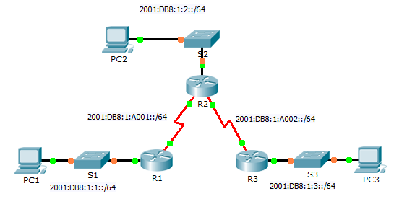

1. IPv6 Addressing Table

|  |  |  |  |
| --- | --- | --- | --- |
| Device | Interface | IPv6 Address/Prefix | Default Gateway |
| R1 | G0/0 | 2001:DB8:1:1::1/64 | N/A |
| S0/0/0 | 2001:DB8:1:A001::1/64 | N/A |
| R2 | G0/0 | 2001:DB8:1:2::1/64 | N/A |
| S0/0/0 | 2001:DB8:1:A001::2/64 | N/A |
| S0/0/1 | 2001:DB8:1:A002::1/64 | N/A |
| R3 | G0/0 | 2001:DB8:1:3::1/64 | N/A |
| S0/0/1 | 2001:DB8:1:A002::2/64 | N/A |
| PC1 | NIC | 2001:DB8:1:1::F/64 | FE80::1 |
| PC2 | NIC | 2001:DB8:1:2::F/64 | FE80::2 |
| PC3 | NIC | 2001:DB8:1:3::F/64 | FE80::3 |

1. Objectives

Part 1: Examine the Network and Evaluate the Need for Static Routing

Part 2: Configure IPv6 Static and Default Routes

Part 3: Verify Connectivity

1. Background

In this activity, you will configure IPv6 static and default routes. A static route is a route that is entered manually by the network administrator in order to create a route that is reliable and safe. There are four different static routes used in this activity: a recursive static route; a directly attached static route; a fully specified static route; and a default route.

1. Examine the Network and Evaluate the Need for Static Routing
   * 1. Looking at the topology diagram, how many networks are there in total? ______5_______
     2. How many networks are directly connected to R1, R2, and R3? ____R1: 2, R2: 3, R2: 2_____________
     3. How many static routes are required by each router to reach networks that are not directly connected?

_____R1: 3, R2: 2 en R: 3_______________________________________________________________

* + 1. Which command is used to configure IPv6 static routes?

___ipv6 route_________________________________________________________________________

1. Configure IPv6 Static and Default Routes
   1. Enable IPv6 routing on all routers.

Before configuring static routes, we must configure the router to forward IPv6 packets

Which command accomplishes this? ______ipv6 unicast-routing_________

Enter this command on each router.

* 1. Configure recursive static routes on R1.

Configure an IPv6 recursive static route to every network not directly connected to R1.

* 1. Configure a directly attached and a fully specified static route on R2.
     1. Configure a directly attached static route from R2 to the R1 LAN.
     2. Configure a fully specific route from R2 to the R3 LAN.   
        **Note:** Packet Tracer v6.0.1 only checks for directly attached and recursive static routes. Your instructor may ask to review your configuration of a fully specified IPv6 static route.
  2. Configure a default route on R3.

Configure a recursive default route on R3 to reach all networks not directly connected.

* 1. Verify static route configurations.
     1. Which command is used in Packet Tracer to verify the IPv6 configuration of a PC from the command prompt?

______ipv6config______________________________________________________________________

* + 1. Which command displays the IPv6 addresses configured on a router's interface?

______show ipv6 interface brief__________________________________________________________

* + 1. Which command displays the contents of the IPv6 routing table? _____show ipv6 route______________

1. Verify Network Connectivity

Every device should now be able to ping every other device. If not, review your static and default route configurations.

1. Suggested Scoring Rubric

|  |  |  |  |
| --- | --- | --- | --- |
| Activity Section | Question Location | Possible Points | Earned Points |
| Part 1: Exam the Network and Evaluate the Need for Static Routing | a - d | 20 |  |
| **Part 1 Total** | | **20** |  |
| Part 2: Configure IPv6 Static and Default Routes | Step 1 | 5 |  |
| Step 5 | 15 |  |
| **Part 2 Total** | | **20** |  |
| **Packet Tracer Score** | | **60** |  |
| **Total Score** | | **100** |  |